**COURSE CODE:** DJS22ITL302 **DATE:5/10/2023**

**COURSE NAME:** Data Structure Laboratory **CLASS: I1-Batch1**

**NAME:** Anish Sharma

**Experiment No. 4**

**CO/LO: CO1**

**Aim: Implementing deque and circular queue.**

#### **Theory:**

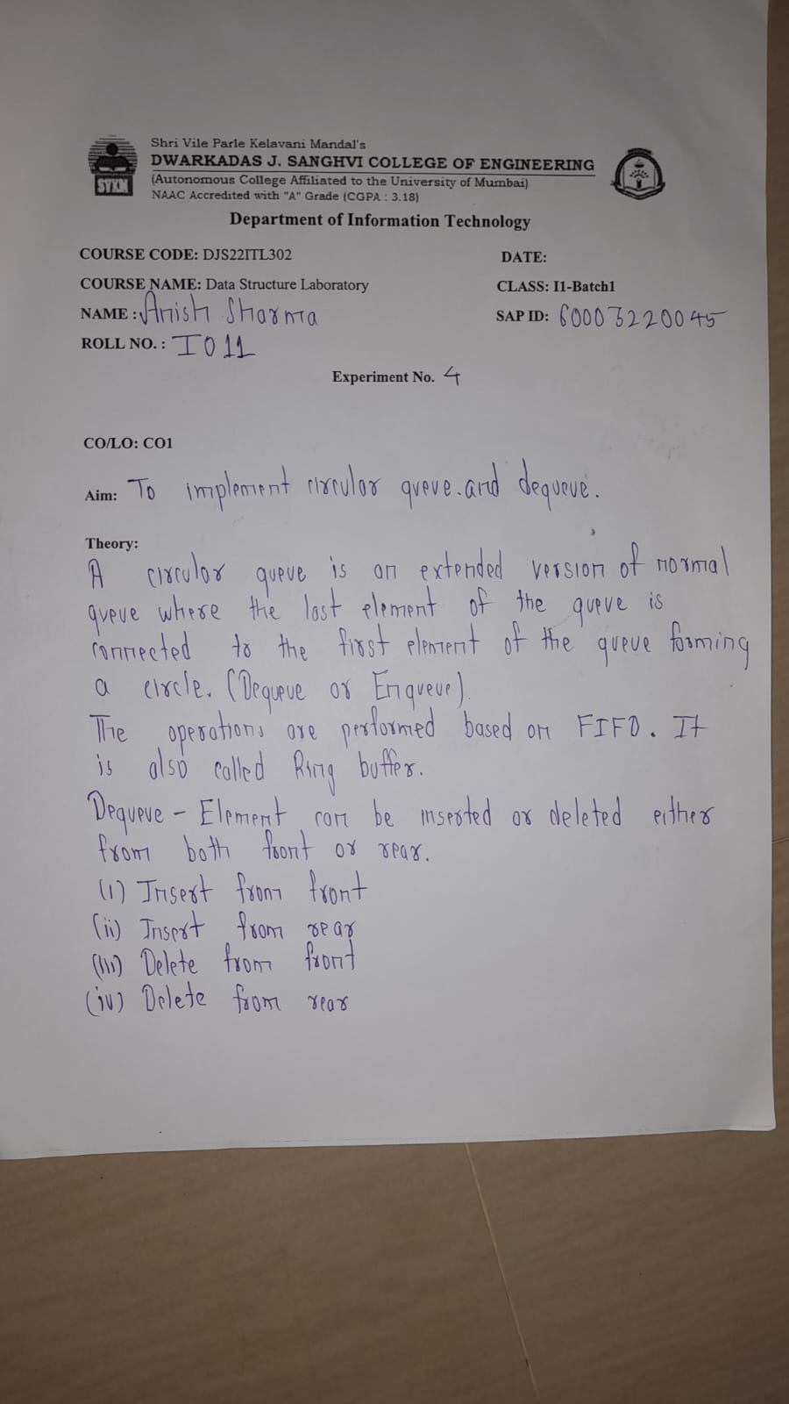

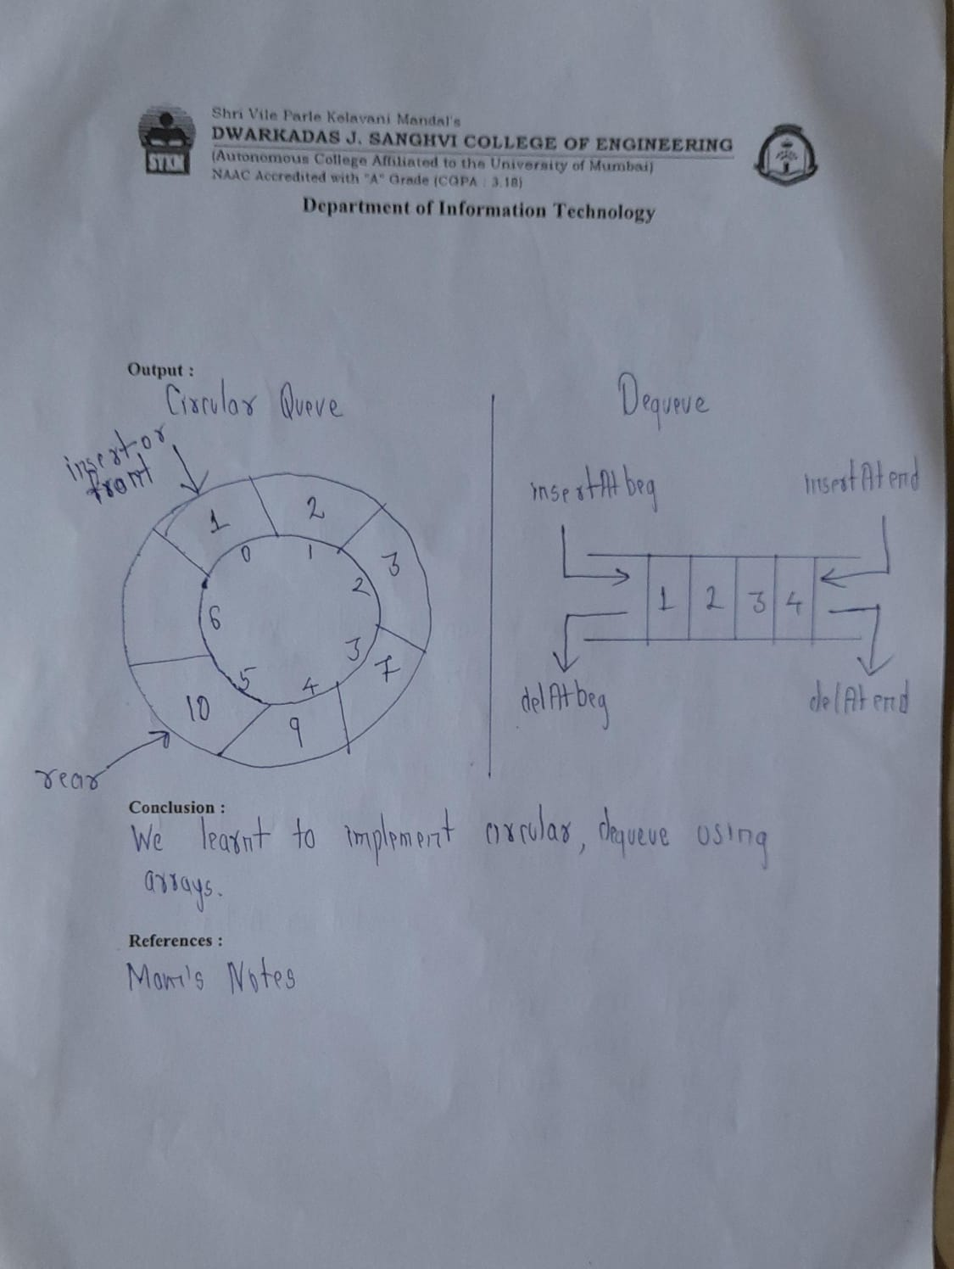

**Circular Queue:**

**A circular queue is similar to a linear queue as it is also based on the FIFO (First In First Out) principle except that the last position is connected to the first position in a circular queue that forms a circle. It is also known as a Ring Buffer.**

**Front: It is used to get the front element from the Queue.**

**Rear: It is used to get the rear element from the Queue.**

**enQueue(value): This function is used to insert the new value in the Queue. The new element is always inserted from the rear end.**

**deQueue(): This function deletes an element from the Queue. The deletion in a Queue always takes place from the front end.**

**Deque:**

**The deque stands for Double Ended Queue. Deque is a linear data structure where the insertion and deletion operations are performed from both ends.**

**Output restricted Queue**

**In output restricted queue, deletion operation can be performed at only one end, while insertion can be performed from both ends.**

**Input restricted Queue**

**In input restricted queue, insertion operation can be performed at only one end, while deletion can be performed from both ends.**

**Program:**

**Circular Queue:**

**#include <stdio.h>**

**#include <stdlib.h>**

**#define size 3**

**int queue[size];**

**int front=-1;**

**int rear=-1;**

**void insert(int x){**

**if(front==-1 && rear==-1){**

**front=rear=0;**

**queue[rear]=x;**

**}**

**else if(front==rear+1 || (front==0 && rear==size-1)){**

**printf("Overflow\n");**

**}**

**else{**

**rear=(rear+1)%size;**

**queue[rear]=x;**

**}**

**}**

**void del(){**

**if(front==-1 && rear==-1){**

**printf("Underflow\n");**

**}**

**else if(front==rear){**

**printf("\nDelete element:%d",queue[front]);**

**front=rear=-1;**

**}**

**else{**

**printf("\nDelete element:%d",queue[front]);**

**front=(front+1)%size;**

**}**

**}**

**void display(){**

**if(front==-1 && rear==-1){**

**printf("There is no element\n");**

**}**

**else{**

**printf("\nDisplaying element:\n");**

**int i=front;**

**while(i!=rear){**

**printf("%d ",queue[i]);**

**i=(i+1)%size;**

**}**

**printf("%d ",queue[i]);**

**}**

**}**

**int main()**

**{**

**int choice,x;**

**printf("Implementation of Circular queue\n");**

**while(1){**

**printf("\nInsertion- 1\nDeletion -2\nDisplay -3\nExit -0\n");**

**scanf("%d",&choice);**

**if(choice==0)**

**break;**

**else if(choice==1){**

**printf("Enter a element:\n");**

**scanf("%d",&x);**

**insert(x);**

**}**

**else if(choice==2){**

**del();**

**}**

**else if(choice==3){**

**display();**

**}**

**}**

**return 0;**

**}**

**Deque:**

**#include <stdio.h>**

**#define size 5**

**int deque[size];**

**int f = -1, r = -1;**

**void insert_front(int x)**

**{**

**if((f==0 && r==size-1) || (f==r+1))**

**{**

**printf("Overflow");**

**}**

**else if((f==-1) && (r==-1))**

**{**

**f=r=0;**

**deque[f]=x;**

**}**

**else if(f==0)**

**{**

**f=size-1;**

**deque[f]=x;**

**}**

**else**

**{**

**f=f-1;**

**deque[f]=x;**

**}**

**}**

**void insert_rear(int x)**

**{**

**if((f==0 && r==size-1) || (f==r+1))**

**{**

**printf("Overflow");**

**}**

**else if((f==-1) && (r==-1))**

**{**

**r=0;**

**deque[r]=x;**

**}**

**else if(r==size-1)**

**{**

**r=0;**

**deque[r]=x;**

**}**

**else**

**{**

**r++;**

**deque[r]=x;**

**}**

**}**

**void display()**

**{**

**int i=f;**

**printf("\nElements in a deque are: ");**

**while(i!=r)**

**{**

**printf("%d ",deque[i]);**

**i=(i+1)%size;**

**}**

**printf("%d",deque[r]);**

**}**

**void getfront()**

**{**

**if((f==-1) && (r==-1))**

**{**

**printf("Deque is empty");**

**}**

**else**

**{**

**printf("\nThe value of the element at front is: %d", deque[f]);**

**}**

**}**

**void getrear()**

**{**

**if((f==-1) && (r==-1))**

**{**

**printf("Deque is empty");**

**}**

**else**

**{**

**printf("\nThe value of the element at rear is %d", deque[r]);**

**}**

**}**

**void delete_front()**

**{**

**if((f==-1) && (r==-1))**

**{**

**printf("Deque is empty");**

**}**

**else if(f==r)**

**{**

**printf("\nThe deleted element is %d", deque[f]);**

**f=-1;**

**r=-1;**

**}**

**else if(f==(size-1))**

**{**

**printf("\nThe deleted element is %d", deque[f]);**

**f=0;**

**}**

**else**

**{**

**printf("\nThe deleted element is %d", deque[f]);**

**f=f+1;**

**}**

**}**

**void delete_rear()**

**{**

**if((f==-1) && (r==-1))**

**{**

**printf("Deque is empty");**

**}**

**else if(f==r)**

**{**

**printf("\nThe deleted element is %d", deque[r]);**

**f=-1;**

**r=-1;**

**}**

**else if(r==0)**

**{**

**printf("\nThe deleted element is %d", deque[r]);**

**r=size-1;**

**}**

**else**

**{**

**printf("\nThe deleted element is %d", deque[r]);**

**r=r-1;**

**}**

**}**

**int main()**

**{**

**insert_front(20);**

**insert_front(10);**

**insert_rear(30);**

**insert_rear(50);**

**insert_rear(80);**

**display();**

**getfront();**

**getrear();**

**delete_front();**

**delete_rear();**

**display();**

**return 0;**

**}**

**Output screenshots:**

**Circular deque:**

#### 

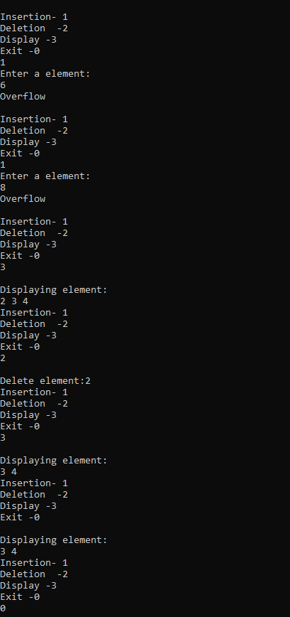

**Deque:**

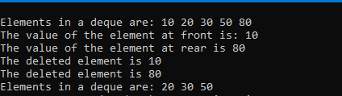

#### **Conclusion:**

I have understood that the concept of deque and circular queue.

**REFERENCES:**

tutorialpoint